

**PROJECT**

**DESIGNATION**

**ABOUT**

**COSY_AIR CONDITIONERS**

Has successfully designed in Cosy_Airconditoners

Page

During E-Project of (1st Semester)

**Aptech worldwide Computer Education**

CERTIFICATE OF COMPLETION

Owais khan

MUHAMMAD Wajid

MUHAMMAD Aamir

**This is Certify that**

**ACKNOWLEDGEMENT**

# **I would like to acknowledge all those who have given me moral support and helped in making the project a success.**

# **I wish to express my gratitude to “E-Project” Team at Aptech Orangi Campus who guided and helped me. Also, I would like to express my gratitude to all the faculty members of my Centre for not only providing me opportunity to work with them on this project, but also for their support and encouragement throughout the process.**

# **I also express my sincere gratitude to E-Project Team from Aptech Orangi Campus and my project guide at the organization for his valuable guidance and support for completion of this project.**

# **Final, I would like to offer many thanks to all my colleagues for their valuable suggestions and constructive feedb**

**PROBLEM STATEMENT:**

COSY AIRCONDITIONERS is selling various types of AIR CONDITIONERS. The

company advertises by distributing the pamphlets, advertising on television and so

on. Due to rapid development in internet field, the company decides to launch a

website where people will get all the information about the various products available

with them easily.

Requirement Specification:

The Web site is to be created based on the following requirements.

1) The Home Page should be created making use of Sections with a suitable

logo.

2) Home Page should contain details of Air Conditioners with suitable images.

3) The site should display a menu which will contain the options for brief

introduction about the various air conditioners available, location of the shop

and any other information if required.

4) The information should be categorized according to the brand names of the

products like if a User wants to see only “WHIRLPOOL” products or any other

companies products then he/she can click on a Link/button/menu etc and can

see only that Brand products.

5) When a user selects any particular brand, a list of products for that brand will

be displayed

6) A brief summary of features of individual products should be displayed on the

Web Page along with the product but detailed Features should be stored in

Individual Word documents which can be downloaded or viewed by the User

who wishes to see the same.

7) The user should also be able to compare the various products of different as

well as similar brands.

8) There should be a “Contact Us” page which will have the Address of the

Company which is as follows and the mail address which when clicked will

invoke the local mail client from where they can send an email.. **requirement specification:**

* Import for Nav bar
* Accept via folders
* Provide mension of Price
* Provide a footer links
* Edit pictures with basic tools

**Gui Design**

**INDEX:** This form serves as main form of the application where user is introduced to the site it also categorizes all the function of the application.

**Image Processing:** In this form the functionality includes image zooming, brightening, contrasting, cropping

**View Slider:** In this website user can view all events papyrus detail and also add new papyrus.

**Create Picture:** In this website information of papyrus.

**Create Sentence:** In this form user can create and customize event passes and can also print them.

**Task sheet**

|  |  |
| --- | --- |
| **Name** | **Contribution in project** |
| **MUHAMMAD AAMIR** | **40%** |
| **MUHAMMAD WAJID** | **30%** |
| **OWAIS KHAN** | **30%** |
|  |  |

**Task sheet**

|  |  |  |  |  |
| --- | --- | --- | --- | --- |
| S.NO | Task | EPROJECT | DONE BY | STATUS |
| 1 | Navigation Bar | Cosy_Airconditioner | M.Aamir | Completed |
| 2 | Slider | Cosy_Airconditioner | M.wajid | Completed |
| 3 | Picture Designed | Cosy_Airconditioner+ | Owais khan | Completed |
| 4 | Pic with Comment | Cosy_Airconditioner | M.wajid | Completed |
| 5 | Price with Picture  Selection | Cosy_Airconditioner | M.Aamir | Completed |

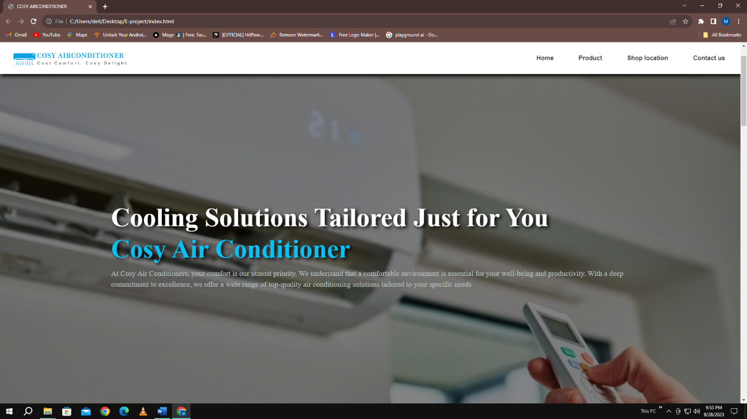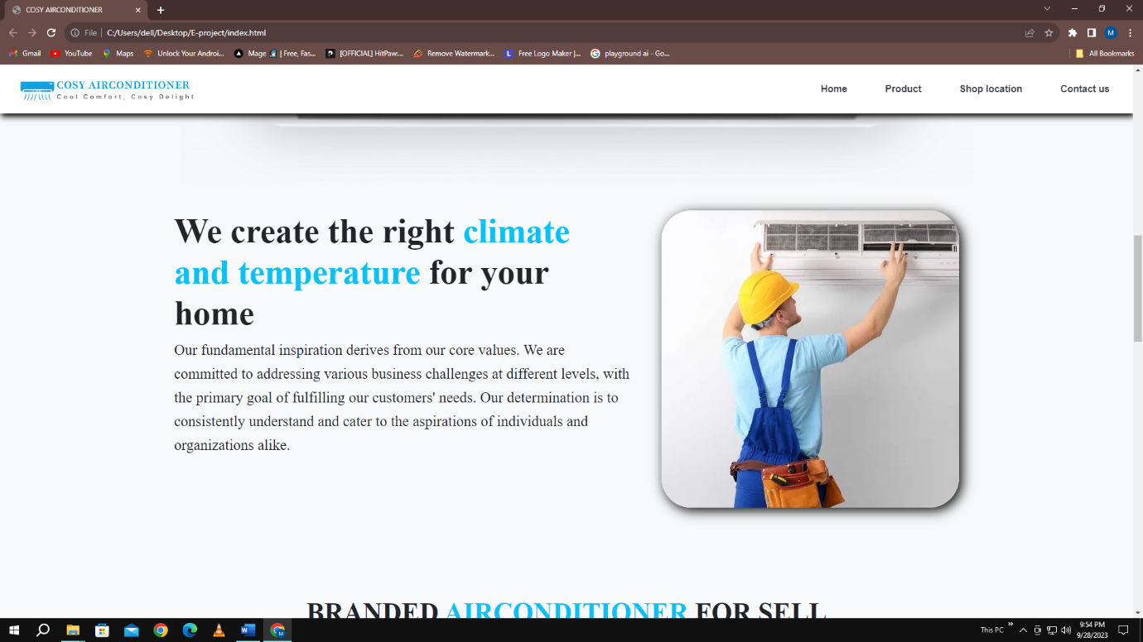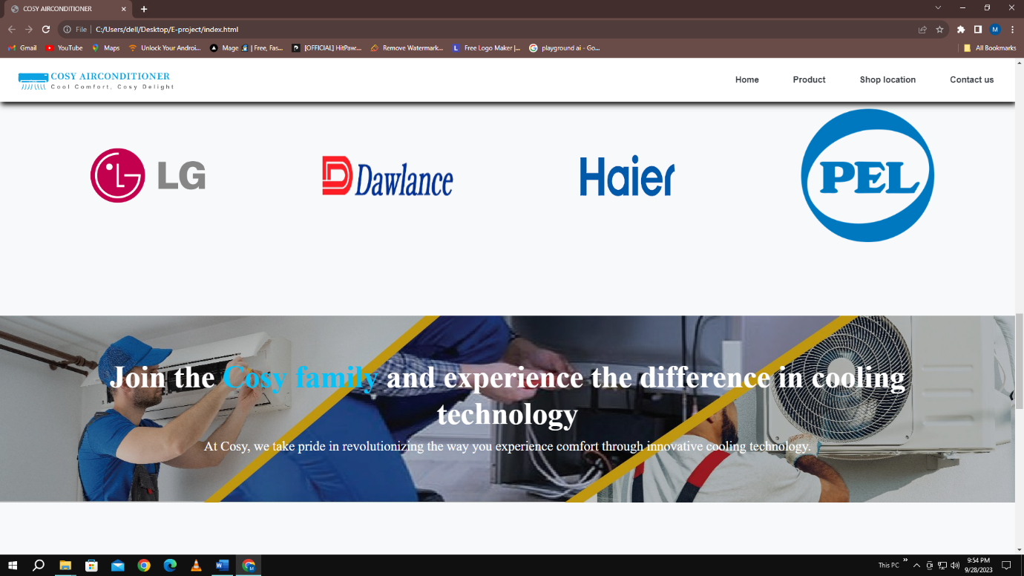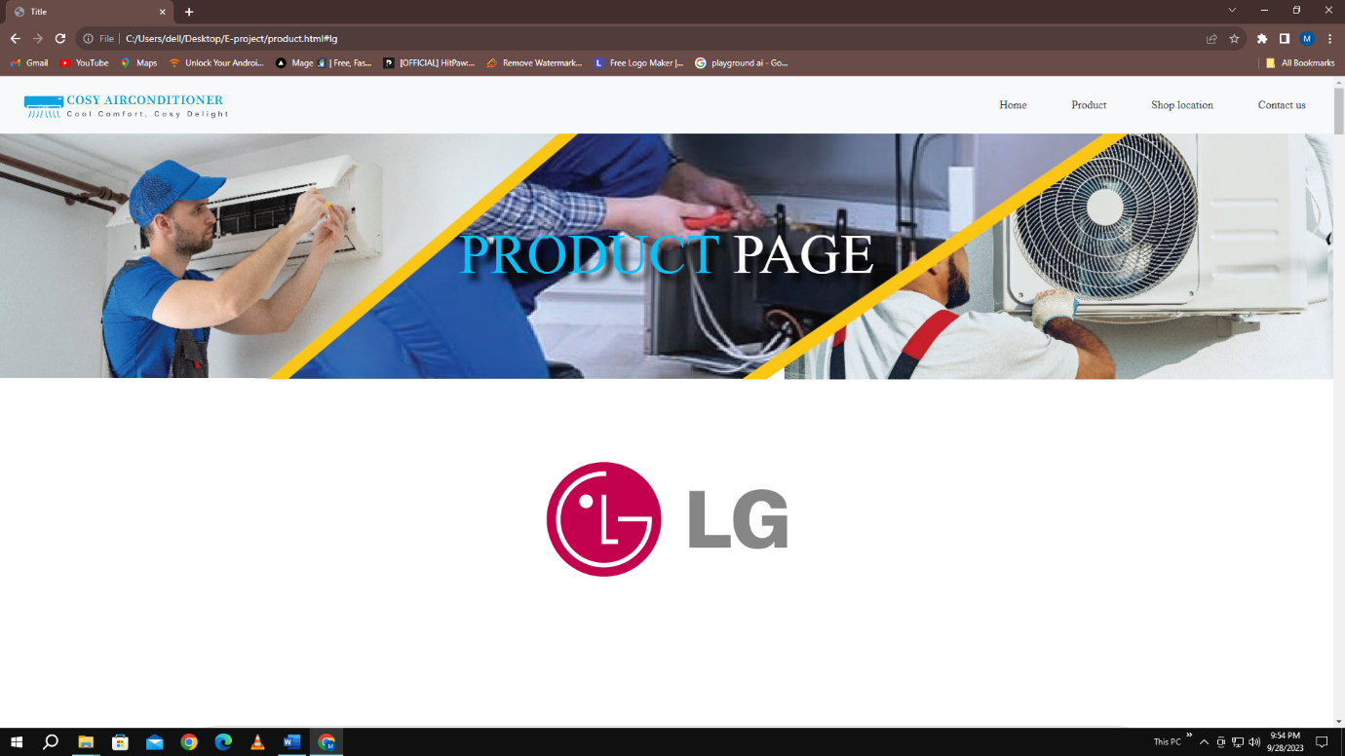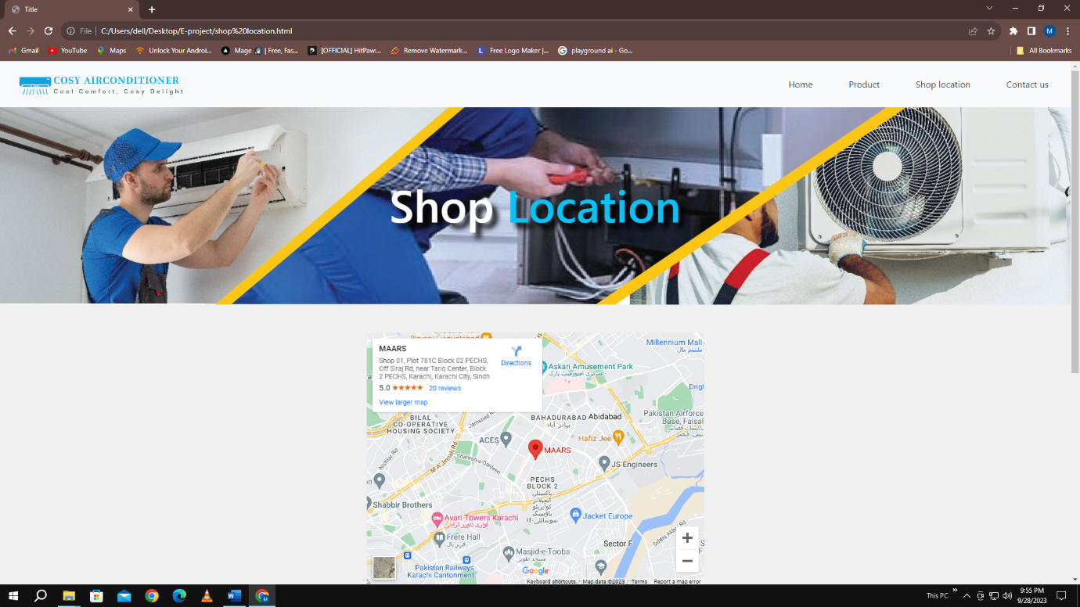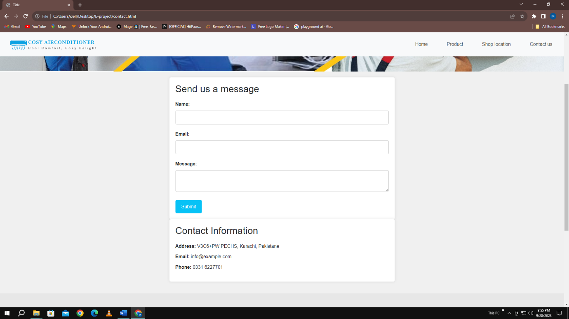**Screenshots**